**MODULE: 1 SE – Overview of IT Industry**

1. **What is software? What is software engineering?**

Software refers to the set of instructions, programs, and data that enable a computer to perform specific tasks or functions. It encompasses everything from operating systems and applications to games and utilities. In essence, software provides the means for users to interact with computer hardware and accomplish various tasks.

Software engineering, on the other hand, is the discipline concerned with the systematic approach to the design, development, testing, and maintenance of software. It involves applying engineering principles and methodologies to create high-quality, reliable, and scalable software systems. Software engineers utilize various techniques, tools, and processes to manage the complexity of software development, ensure its correctness, and meet the needs of users and stakeholders. Key aspects of software engineering include requirements analysis, software design, coding, testing, debugging, and software maintenance.

1. **Explain types of software**

1. System Software: This type of software provides a platform for other software to run on. It includes operating systems like Windows, macOS, and Linux, as well as device drivers, utilities, and firmware.

2. Application Software: Application software is designed to perform specific tasks or functions for end-users. This category includes a wide range of software, such as word processors, spreadsheets, web browsers, email clients, multimedia players, and graphic design tools.

3. Programming Software: Programming software provides tools for developers to create, debug, and maintain software applications. Integrated Development Environments (IDEs) like Visual Studio, Eclipse, and IntelliJ IDEA fall into this category, along with compilers, interpreters, and debuggers.

4. Middleware: Middleware acts as a bridge between different software applications or components, enabling them to communicate and interact with each other. Examples include web servers, application servers, and database management systems.

5. Enterprise Software: Enterprise software is designed to address the needs of organizations and businesses. It includes software for enterprise resource planning (ERP), customer relationship management (CRM), supply chain management (SCM), and business intelligence (BI).

6. Content Management Software: Content management software enables users to create, manage, and publish digital content. Examples include content management systems (CMS) like WordPress, Joomla, and Drupal, as well as digital asset management (DAM) systems.

7. Educational Software: Educational software is designed to facilitate learning and educational activities. It includes tools for teaching, learning management systems (LMS), educational games, simulations, and e-learning platforms.

8. Entertainment Software: Entertainment software provides users with recreational and leisure activities. This category includes video games, multimedia applications, virtual reality (VR) experiences, and streaming media services.

1. **What is SDLC? Explain each phase of SDLC**

SDLC stands for Software Development Life Cycle. It is a structured process used by software development teams to plan, design, build, test, deploy, and maintain software applications. The SDLC consists of several phases, each with its specific objectives, deliverables, and activities. The common phases of the SDLC are as follows:

SDLC stands for Software Development Life Cycle. It's a process used by software development teams to design, develop, test, and deploy high-quality software. The typical phases of SDLC are:

1. Planning: Defining project scope, requirements, and objectives.

2. Analysis: Gathering requirements and analyzing them to understand the needs of stakeholders.

3. Design: Creating a detailed design plan based on the requirements gathered.

4. Implementation: Writing code and developing the software based on the design.

5. Testing: Conducting various tests to ensure the software meets quality standards and functions correctly.

6. Deployment: Releasing the software to users or customers.

7. Maintenance: Providing ongoing support, updates, and enhancements to the software as needed.

1. **What is DFD? Create a DFD diagram on Flipkart**

DFD stands for Data Flow Diagram. It is a graphical representation of the flow of data within a system, illustrating how data is input, processed, stored, and output. DFDs are commonly used in software engineering to model the functional aspects of systems.

Creating a complete DFD for a complex system like Flipkart would require detailed analysis of its various components and processes. However, I can provide a simplified example of a DFD for a basic aspect of Flipkart's functionality, such as the process of placing an order.

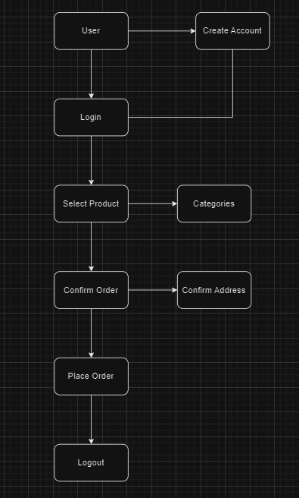

1. **What is Flow chart? Create a flowchart to make addition of two numbers**

A flowchart is a visual representation of a process or algorithm, typically using standardized symbols to depict the steps involved and the flow of data or control from one step to the next. It is commonly used in various fields, including software development, business processes, and engineering, to illustrate the logical flow of operations.

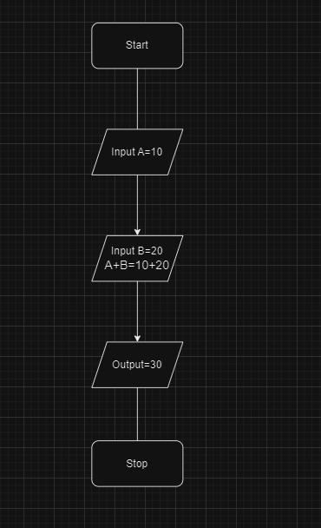

1. **What is Use case Diagram? Create a use-case on bill payment on paytm.**

A use case diagram is a visual representation of the interactions between actors (users or external systems) and a system, showcasing the various use cases or functionalities the system provides. It helps in understanding the system's behavior from the perspective of different stakeholders.

